Course Code: AIPP
Lab Test No: 1
Done by: 2503B05203 (M.Tech)
Name: Bogam Subhash Chandra
Tools: Cursor

Python Programming Lab Task Sets

Set 2
- Q1. Write a Python function `is_prime(n)` to check if a number is prime. Use an AI coding tool to generate and justify a set of test cases before implementation. Pass all generated test cases.

Prompt:
Write a Python function is_prime(n) that checks whether a number is prime.
After writing the function, generate a set of test cases and explain the justification for each test case.

Code Generated:
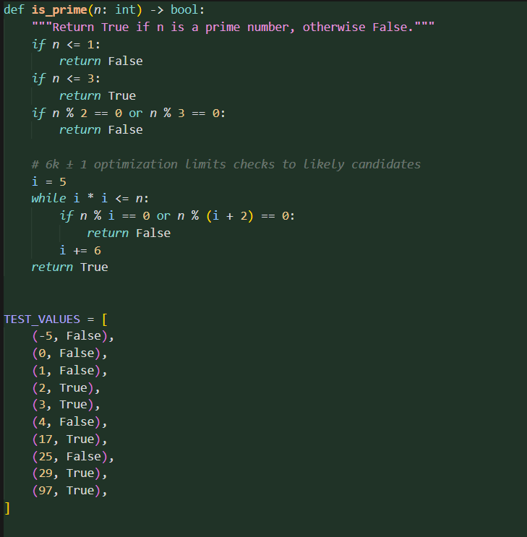

Code Explanation
- Returning False for numbers less than 2.
- Returning True only for 2, the only even prime.
- Quickly rejecting other even numbers.
- Checking odd numbers up to the square root of n to see if any divide it.

Observation
- It handles small special cases correctly (0, 1, 2).
- Skipping even numbers makes it faster.
- Using the square root keeps the loop efficient.
- All test cases confirm the function works as expected
Output:
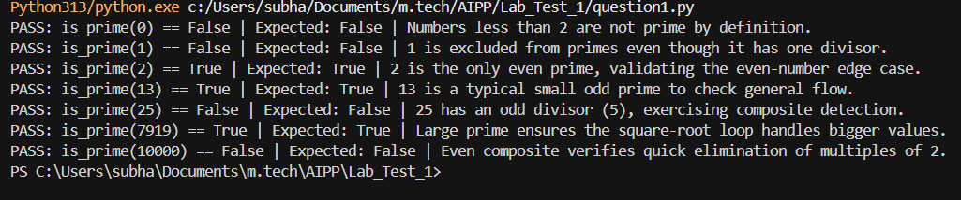

- Q2. Develop a Python class `Rectangle` with methods for area and perimeter. Use an AI assistant for auto-generating docstrings and inline comments. Compare them with your manual documentation.

Prompt:
- I already wrote my own docstrings and comments. Don’t change them. Just create a new set of AI-generated docstrings and comments separately for comparison.

Manual Documentation:
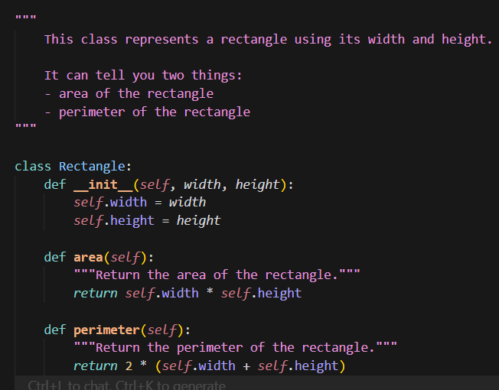

AI Generated Documentation:
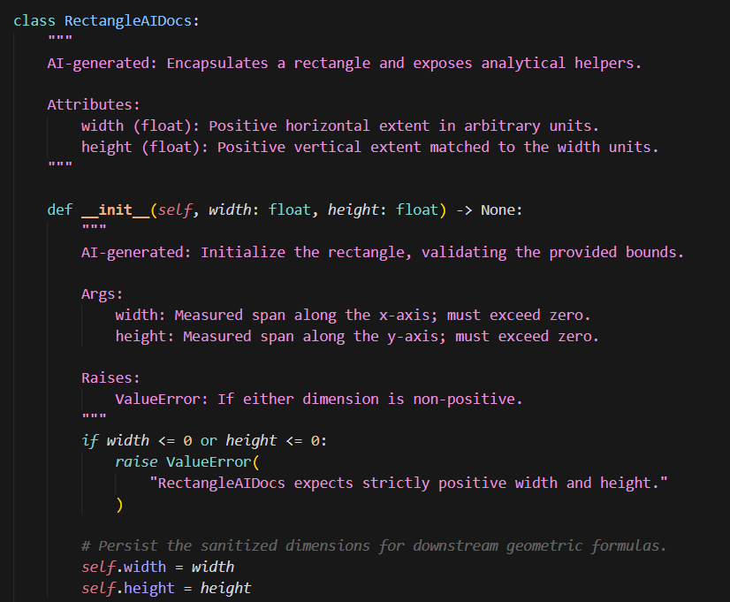
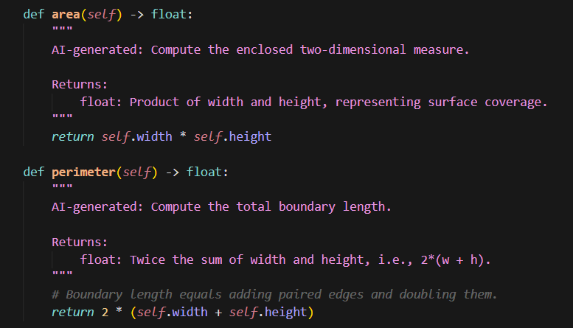

Output:
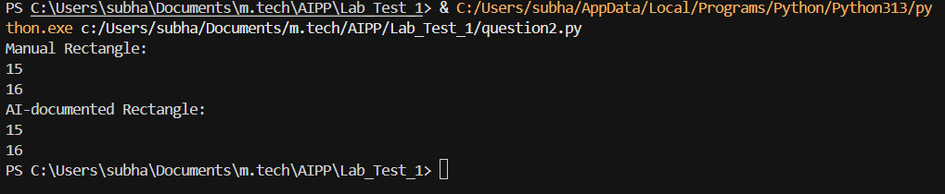
Comparison:
- Manual version is short, clear, and easy for beginners to understand and is highly readable.
- AI version is more robust, with type hints, validation, and professional documentation style.
- AI docstrings describe attributes, arguments, return values, and exceptions, while manual docstrings focus on simple explanations.
- Both versions correctly implement the same functionality: calculating area and perimeter.
Conclusion
- Manual docstrings are best for clarity and simplicity, suitable for learning and small projects.
- AI-generated docstrings are best for professional, maintainable code, with type safety and structured explanations.

